Camrose High School students parents,

Camrose High School with Castle Rock Research has arranged for students to receive a special discount on study guides for grades 3-12 in Mathematics, English Language Arts, Science and Social Studies.

These print and digital resources are aligned to the Alberta curriculum, and are all updated to reflect the 2023-24 curriculum. They are a great support for all students, including those taking diploma exams representing 30% of their final marks.

Check out the options and visit https://schoolorders.solaro.com/4545 to place your order between February 2 and February 16. Orders will be individually packaged and shipped to the school for pick up by your students within a week of closing.
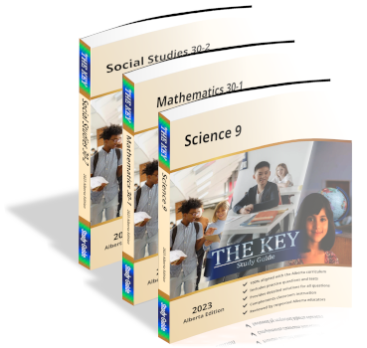
The KEY Study Guides, $25.00 per copy ($34.99 retail)
- Mathematics, English Language Arts, Science and Social Studies editions have been updated for the 2023-2024 school year
- New Pre-Test/Post-Test sections (Pre-Tests assess skills from the previous grade, Post-Tests reflect course content in which students must demonstrate proficiency)
- Grade 12 Math and Science resources have been updated to include questions from recently released Diploma exams.

Student Notes and Problems (SNAP) Workbooks, $25.00 per copy ($34.99 retail)
Instructional content, practice exercises and unit assessments covering the breadth and depth of select Science and Mathematics courses.

Problem Solved and Class Notes, $17.00 per copy ($24.95 retail)
All of the questions from the respective SNAP workbooks are presented along with the detailed solutions. Included are excerpts that focus students on the explanatory notes for each topic.
SOLARO – $25.00 for an annual student license ($200 retail)
- 1-year access to up to 10 courses across grades 3-12 in Mathematics, English Language Arts, Science, and Social Studies, available on any desktop, laptop or mobile browser
- Offers more courses than are available in print, 10x the practice questions compared to print, plus tests and additional study tools

Thank you,
Camrose High School

